**COIT20258-Software Engineering**

**SA Assessment 2**

Test Plan

Test Plan

Student Name: Bishal Budhathoki

Student ID: 12116421

Lecturer: Dennis Jarvis

Tutor: Dennis Jarvis

Unit Coordinator: Dennis Jarvis

CQUniversity, Sydney

# Test Plan

Before Doing any testing these are the data already, we are dealing with and are stored in database.

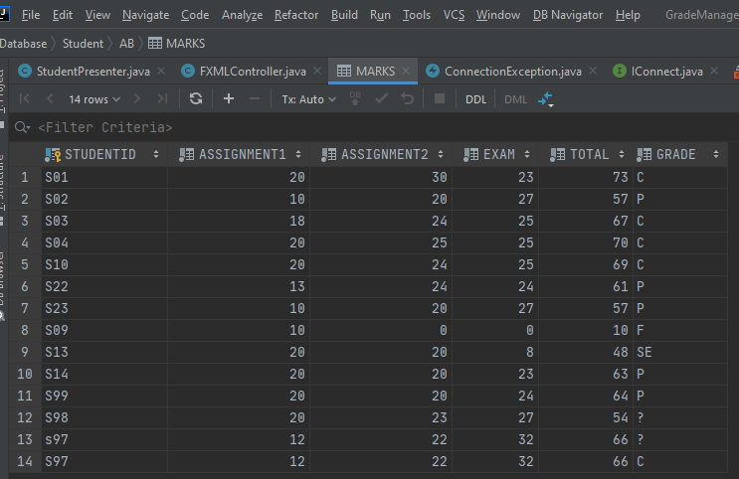

|  |  |
| --- | --- |
| Basic Functionality | Correct |

|  |  |  |
| --- | --- | --- |
| 1. Use Case 1 | Grade Calculation for individual or all student and display records in a text area |  |
| 1. Accurate Calculation of total marks for a given student | Input:  Student ID = S23, Assessment 1 = 18, Assessment 2 = 26, Exam = 27.5  Output: Total = 71.5  Total = Assessment 1 + Assessment 2 + Exam  = 18 + 26 + 27.5  = 71.5 | Yes |
| 1. Calculation of Grade for a given student after calculation of total marks | Input:  Student ID = S23, Assessment 1 = 18, Assessment 2 = 26, Exam = 27.5, Total = 71.5  Output: Grade = C  For Grade C, 65 <= Total <= 74  Total is in the range, Grade is C | Yes |
| 1. Find Student whose grade is not calculated | (NOTE: Grade calculation for all works if there is entry in records using SQL Query as provided in Assignment 1 Specification where ? denotes no data, as this system does not store data provided only StudentID, Assignment 1 & 2 marks and exam marks)  Input from SQL Query  INSERT INTO MARKS(STUDENTID,ASSIGNMENT1,ASSIGNMENT2,EXAM,TOTAL,GRADE)  VALUES  ('S98',20,23,27,54,'?'),  ('s97',12,22,32,66'?');  Output: Display Data of students whose grade is not calculated and denoted by ?  Output has data with Grade = ? | Yes |
| 1. Calculation of Grade for All Student | Input:  Student ID = 'S98', Assessment 1 = 20, Assessment 2 = 23, Exam = 27, Total = 54  Output: Grade = C, total = 70  For Grade C, 65 <= Total <= 74  Total is in the range, Grade is C  Total was wrong, it was 54 but should be 74 and total = 74, corrected. | Yes |
| 1. Display the updated records in a text area | Expected output: Every required text field be filled with required data respectively.  Output: On every test case above the data were correctly displayed and to view next concurrent data previous and next button is used and works correctly. | Yes |

|  |  |  |
| --- | --- | --- |
| 1. Use Case 2 | Update an entry for a student like marks for one or more assessment items and display the updated record in a text area. |  |
| 1. Update an entry for a student | Input: Existing Data  Student ID = S01, Assessment 1 = 20, Assessment 2 = 30, Exam = 23, Total = 73, Grade = C  Updated Data: Assessment 1 = 18, Assessment 2 = 28, Exam = 27  Output: Grade = C, total = 73  After selecting Calculate Grade Button output data is matched.  On selecting Update Button, Data is updated for that specific student ID. | Yes |
| 1. Display the updated record in text area | Expected output: Every required text field be filled with required updated data respectively. Assessment 1 = 18 , Assessment 2 = 28, Exam = 27, total = 73, Grade = C  Output: On every test case above the data were correctly displayed and to view next concurrent data previous and next button is used and works correctly. | Yes |

|  |  |  |
| --- | --- | --- |
| 1. Use Case 3 | Find Borderline Cases and Range Data in a certain range provided |  |
| 1. Set the Tolerance value and display borderline case | (NOTE: By default, the tolerance value is set to 2)   1. If no tolerance value is entered, output is the data that is near to next grade if total marks is favourable to next grade if added 2 or less marks.   Output should be 4 student data with Student ID = S01, S13, S14, S99 and Total = 73, 48, 63, 64 respectively.  Obtained output is same as expected output displayed.   1. If tolerance value is entered, here tolerance value entered is 1 and the data that is near to next grade if total marks is favourable to next grade if added 1 or less marks is displayed.   Output should be 4 student data with Student ID = S99 and Total = 64 respectively.  Obtained output is same as expected output displayed. | Yes  Yes |
| 1. Select the range and display data in that range | Input :  Range = 50 – 64  Output: Data of 5 student is to be displayed with Student ID S02, S22, S23, S14, S99.  All 5 student details are displayed on the text area and considering the total marks of each student 57, 61, 57, 63, 64 respectively, they are in the range selected. | Yes |

|  |  |  |
| --- | --- | --- |
| 1. Use Case 4 | Browser Query Results as per AddressBook using Previous and next buttons with wrap around functionality for above 3 use cases |  |
| 1. Obtain the data specific to the query provided for each use case above | 1. Browsing of all the records in the database   Input: Data stored using SQL Query manually or using the GUI.  Output: All records of data that is entered and stored in database is to be displayed and visit using previous and next button.  After selecting the Browse button, all 14 student data record is loaded and can be accessed individually using previous and next button. | Yes |
|  | 1. Find Student record specific to the Student ID   Input: Student ID = S99  Output: Assessment 1 = 20, Assessment 2 = 20, Exam = 24, total = 64, Grade = P  Obtained output is matched. | Yes |
|  | 1. Every other record that is either modified, updated or some query action is performed is to be displayed   Input: Calculate Grade, Update, Save Data, Grade All Button selection which executes individual query.  Output: Obtained record as per previous and next button.  Obtained output is matched and displayed along with previous and next button performance. | Yes |

|  |  |  |
| --- | --- | --- |
| 1. Use Case 5 | Display all student record who have obtained specific grade and maintained in order of increasing mark. |  |
| 1. Obtain the   data specific to the query provided for obtaining record specific to grade and in order of increasing marks | Input:  Grade = P  Output: Data of 5 student is to be displayed with Student ID S23, S02, S22, S14, S99. The record should be displayed in increasing total marks order.  Student details are displayed on the text area and considering the total marks of each student 57, 57, 61, 63, 64 respectively, they are in the range of P and in increasing total marks order. | Yes |
|  |  |  |

|  |  |  |
| --- | --- | --- |
|  | Managing Input Errors |  |
| 1. If Student ID that exist in the database is tried to save on database | Input: Student ID = S99  Output: Insert Command Not executed | Yes |
| 1. If Student ID that exist in the database is tried to save on database after doing update | Input: Student ID = S99, select find button, select update and then save data button  Output: Data exist in database alert | Yes |
| 1. Assignment 1 marks greater than 20, Assignment 2 marks greater than 30 exam marks greater than 50, total greater than 100 | Input Assignment 1 = 30, Assignment = 40, Exam = 60  Output: | Yes |
| 1. Tolerance value set to 0 or less | Input: Enter Tolerance = 0 or -1  Output: | Yes |
| 1. If no Range is selected from the combo box | Input: Select Filter By Range Button but no range from the combo box  Output: | Yes |
| 1. If no grade is selected from the combo box | Input: Select Filter By Grade Button but no Select Grade from the combo box  Output: | Yes |
| 1. If no student ID is entered and Find button is selected | Input:  Student ID:  Output: | Yes |
| 1. If previous button is selected when there is no record do display | Input:  Previous Button is selected  Output: | Yes |
| 1. If next button is selected when there is no record do display | Input:  Next Button is selected  Output: | Yes |

This is the data after doing all the testing.

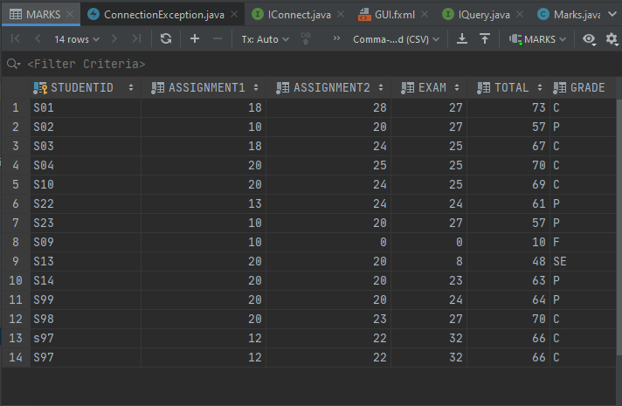

Main Page User Interface:

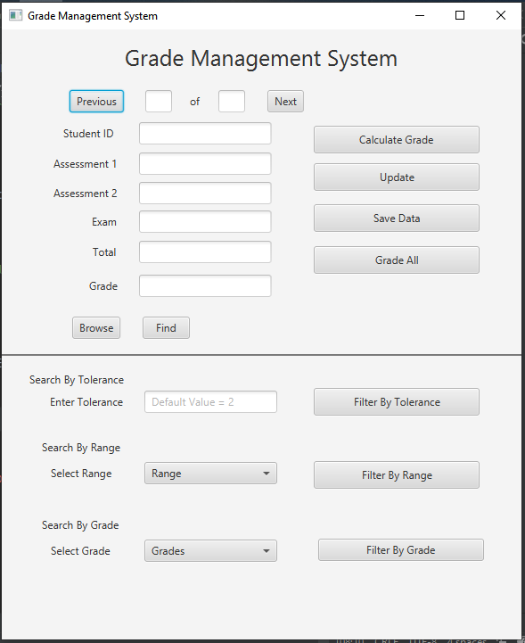

**Limitations:**

Considering all the functionality required in the specification, the program is running smoothly and calculate required data and queries and outputs the data required; however, some limitation is found.

1. Data of the student should be complete. Only marks providing would not be enough, there grade calculation must be done and then saved in the database else system will not save in the database.
2. Direct grade calculation is not possible, selecting grade all button will obtain data of the student whose grade is to be calculated and selecting Calculate grade button will calculate their grade and then can be updated. Use of previous and next button makes easier.

Thank You